Transmission Line Ratings

The multi-nodal model has transmission lines which enable power to flow between regions. Due to the physical properties of these transmission lines, the amount of electricity that they can carry is limited, typically by their thermal limit. To model the limited power flow that can occur between the regions of SA, the current transmission infrastructure is explored.

Data presented in the sections below is from ElectraNet’s transmission annual planning report additional resources, in conjunction with AEMO’s transmission equipment ratings document.

One important note about the transmission line limits is that ElectraNet provides them in MVA rather than in MW. However, after looking through their TAPR and comparing the transmission line ratings of Heywood and the DC Murraylink interconnectors, it is assumed that the transmission lines operate at a unity power factor. This is also justified by Table S5.3.1 of the Rules [96]. Another note is that it is assumed all regions mentioned in this section are honours regions unless specified otherwise.

Outlined in the discussion below is a detailed analysis of the transmission lines that connect regions. The most up to date Australian Government database is used to visually display the transmission lines in Google Earth Pro [172].

# Adelaide Metro to Mid North

The Adelaide Metro region is connected to one other honours region, the Mid North region. These connections are highlighted in Figure 1 below. The three connection groups are addressed in the following discussion.

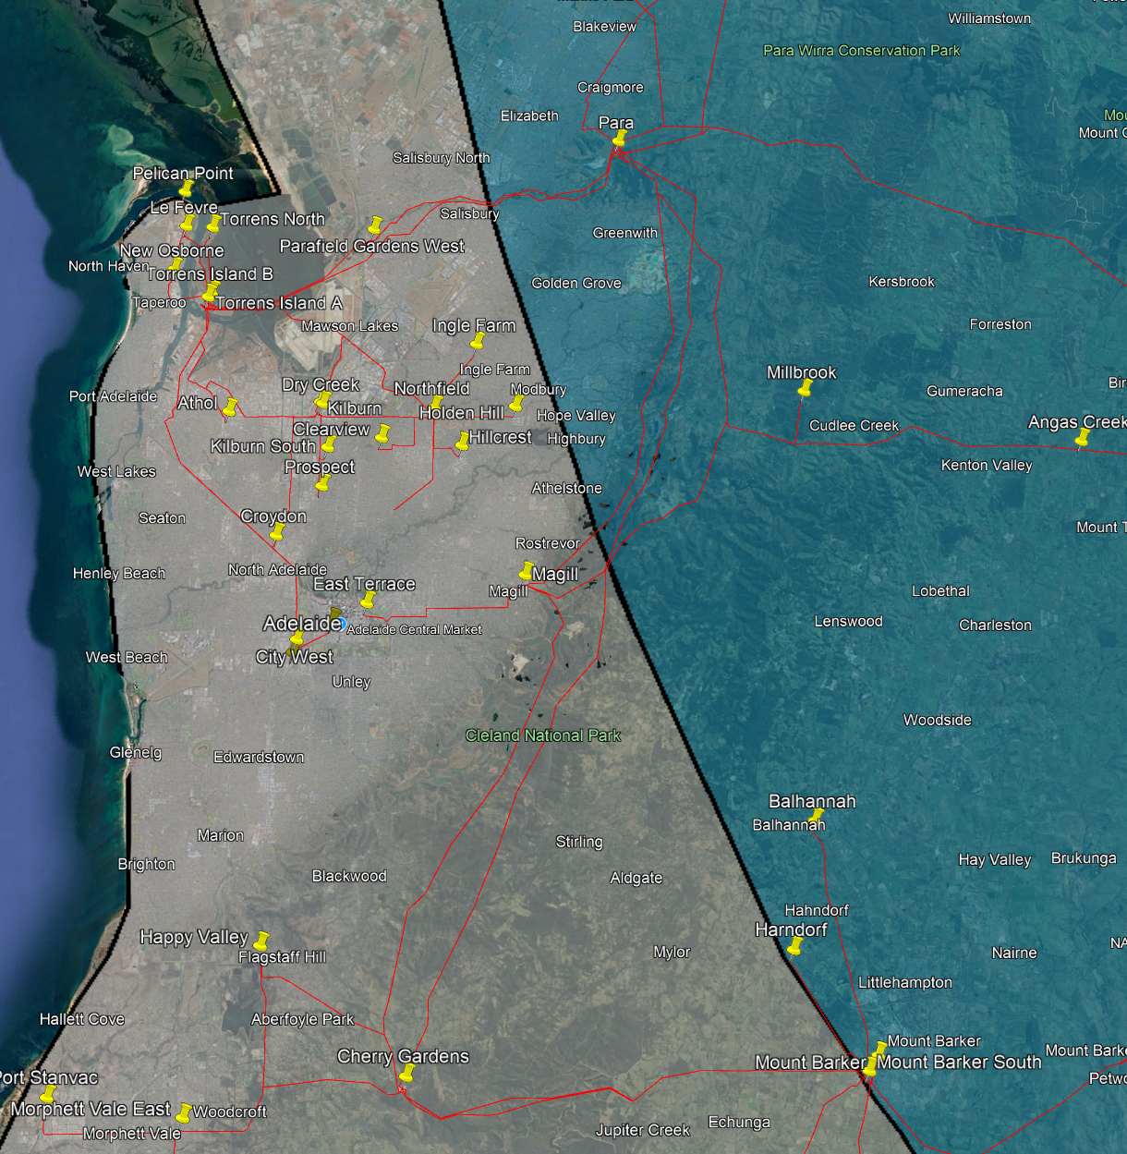



**Figure 1:** Adelaide Metro and the Mid North transmission line connections.

The first set of transmission lines from Adelaide Metro to Mid North are shown in Figure 2 below. Although not clearly visible in the figure, the top transmission line is a double circuit line, containing Torrens Island Power Station (TIPS) B to Cherry Gardens substation and Parafield Gardens West to Para. The transmission line running from TIPS B to Cherry Gardens passes over Para substation but does not tee in, and therefore is not counted in the transmission limits. Parafield Gardens West to Para is a 275kV line with a rating of 714MW. The bottom transmission line is from TIPS A to Para. TIPS A to Para substation is a 275kV line with a rating of 714MW.

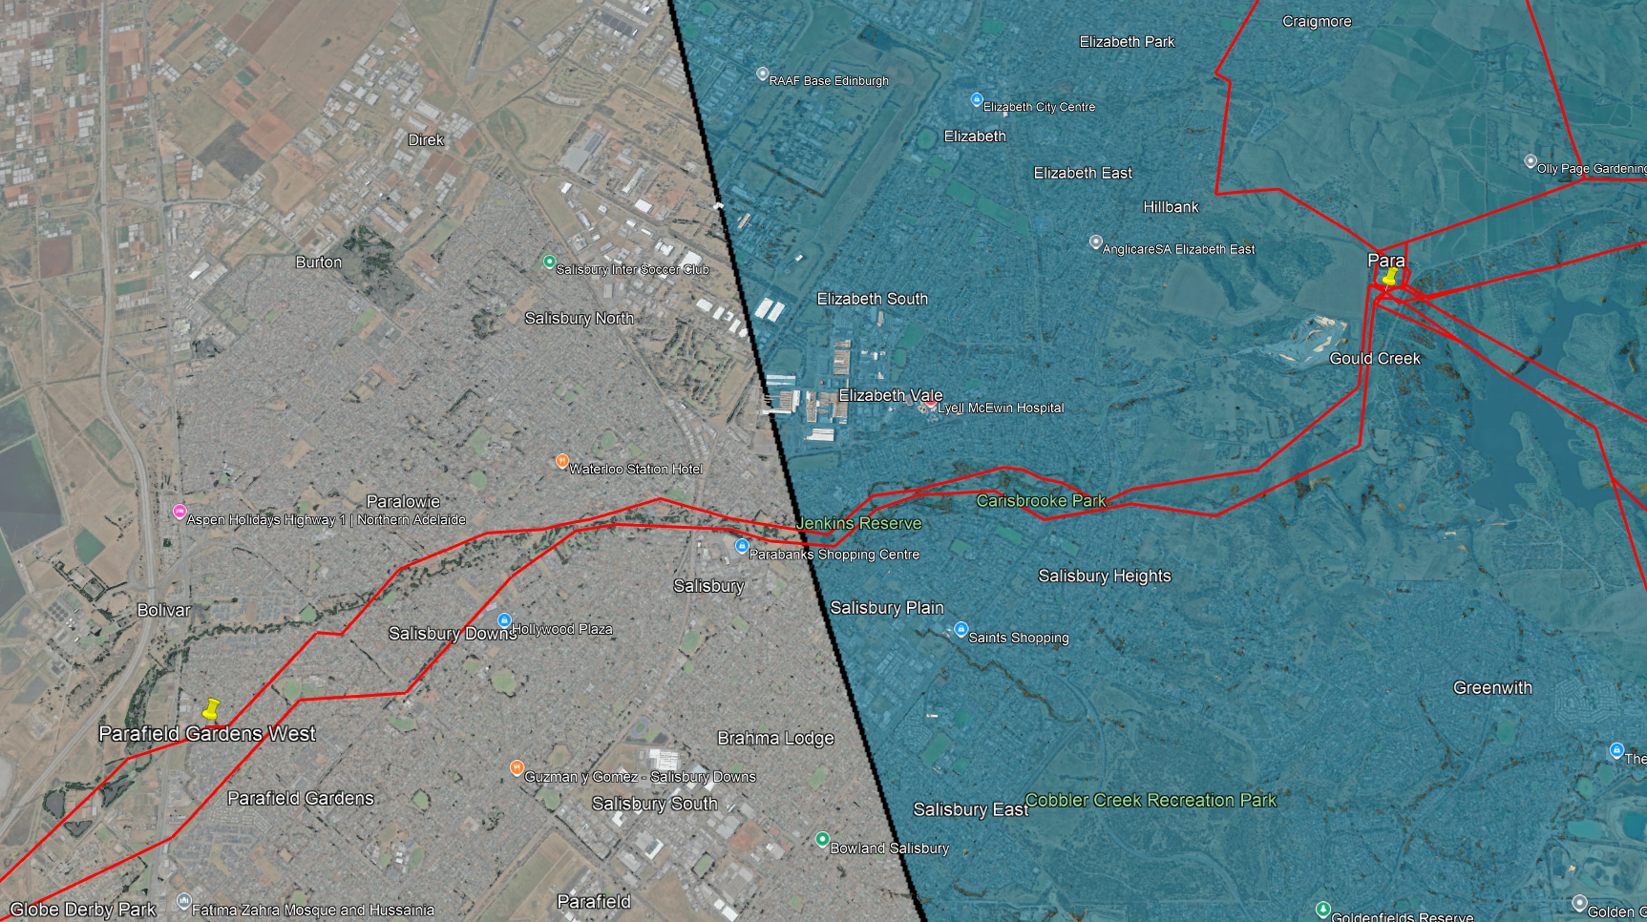

**Figure 2:** Close up of the first group of transmission lines connecting Adelaide Metro to the Mid North region.

Figure 3 shows the next lot of transmission lines from Adelaide Metro to Mid North. From top to bottom, the Magill to Para 275kV line has a rating of 600MW, the TIPS A to Magill 275kV line and the TIPS B to Cherry Gardens 275kV line are not counted here as they run between two Adelaide Metro substations.

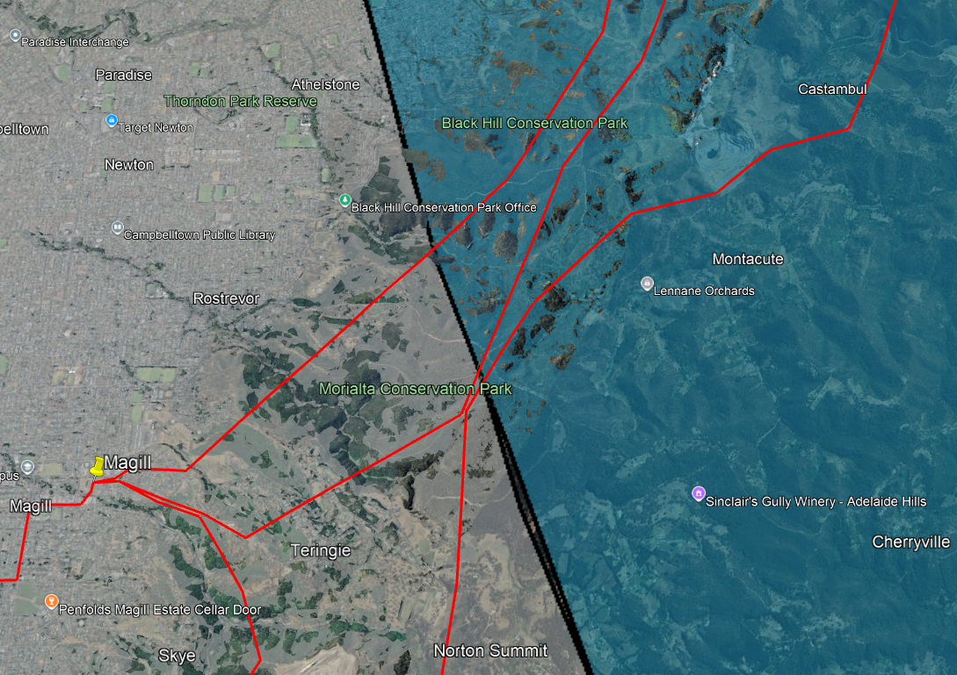

**Figure 3:** Close up of the second group of transmission lines connecting Adelaide Metro to the Mid North region.

The final group of transmission lines from Adelaide Metro to the Mid North are shown in Figure 4 below. The three lines of interest are displayed as a single transmission. The Cherry Gardens to Mt Barker South 275kV line has a rating of 1072MW, the Cherry Gardens to Mt Barker 132kV line has a rating of 182MW, and finally, the Cherry Gardens to Tungkillo 275kV line has a rating of 1143MW.

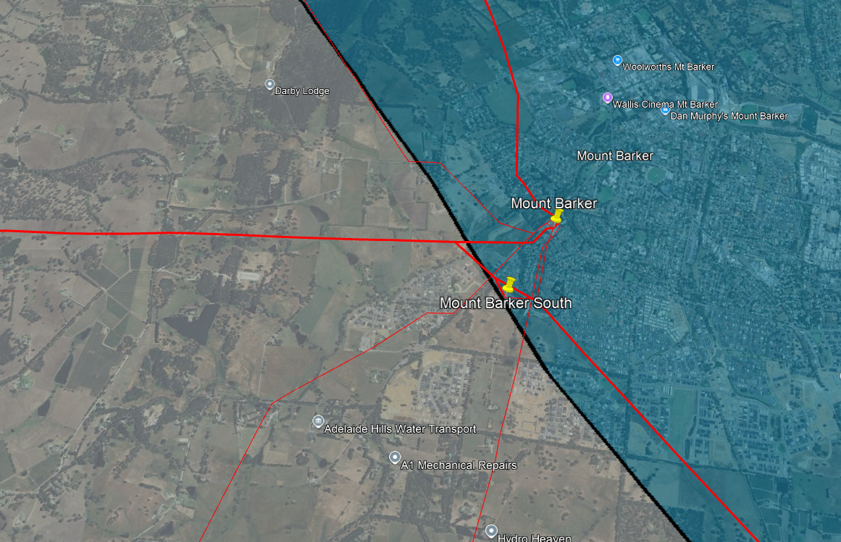

**Figure 4:** Close up of the second group of transmission lines connecting Adelaide Metro to the Mid North region. The thinner transmission lines are 66kV and are not considered as they are part of the distribution network not the transmission network.

Thus, the total transmission capacity between Adelaide Metro and the Mid North is 4425 MW as shown in Table 1 below.

**Table 1:** Summary of the transmission lines connecting the Adelaide Metro region to the Mid North.

|  |  |  |  |
| --- | --- | --- | --- |
| Adelaide Metro Substation | Mid North Substation | Voltage (kV) | Rating (MW) |
| TIPS A | Para | 275 | 714 |
| Parafield Gardens West | Para | 275 | 714 |
| Magill | Para | 275 | 600 |
| Cherry Gardens | Mt Barker South | 275 | 1072 |
| Cherry Gardens | Mt Barker | 132 | 182 |
| Cherry Gardens | Tungkillo | 275 | 1143 |
| **Total** |  |  | **4425** |

# Eyre Peninsula to Iron Triangle

There is a single transmission line connecting the Eyre Peninsula region to the Iron Triangle as shown in Figure 5. This is the double circuit Cultana to Yadnarie 132kV line. The first circuit is rated at 230MW, and the second circuit is rated at 266MW. Therefore, the total transmission capacity between the Eyre Peninsula and the Iron Triangle is 496MW.

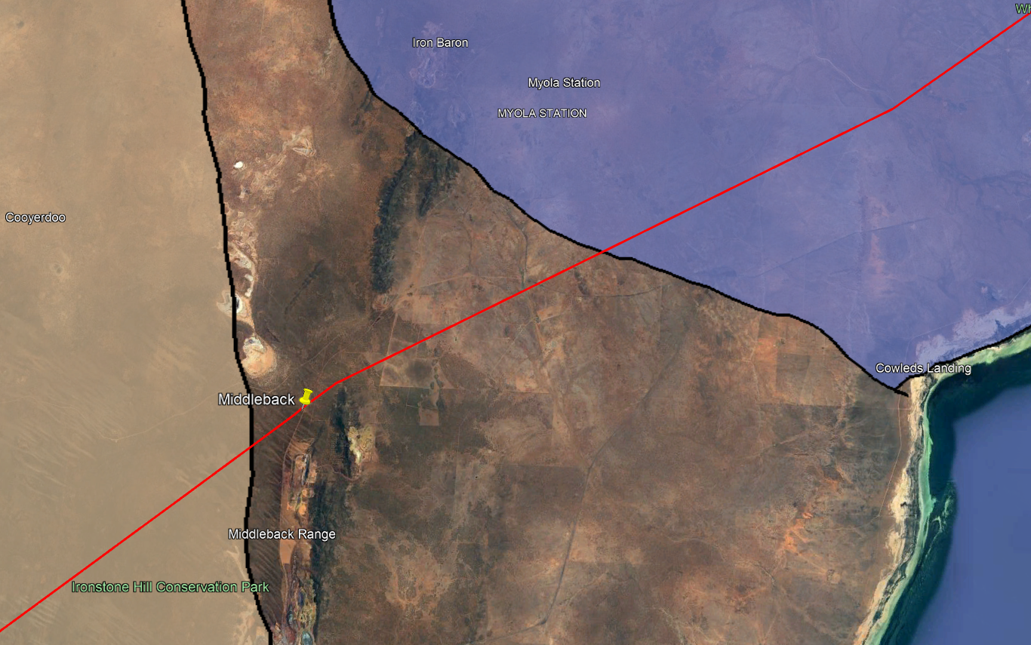

**Figure 5:** Eyre Peninsula and the Iron Triangle transmission line connections.

# Iron Triangle North to Upper North

As displayed in Figure 6, there are multiple transmission lines connecting the Iron Triangle to the Upper North. From left to right, the transmission lines are Davenport to Mount Gunson South 275kV line rated at 381MW, Davenport to Mount Gunson tee 132kV line rated at 61MW, two Davenport to Olympic Dam 275kV circuits rated at 381MW and 522MW, respectively, and Davenport to Neuroodla tee 132kV rated at 10MW. The total transmission capacity between between the Iron Triangle and the Upper North is thus 1355MW as summarised in Table 2 below.

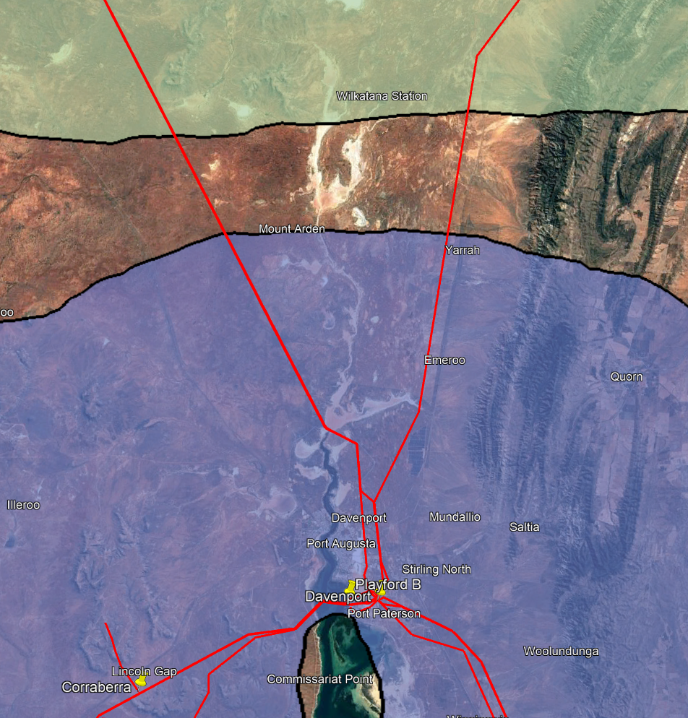

**Figure 6:** The Iron Triangle to the Upper North transmission line connections.

**Table 2:** Summary of the transmission lines connecting the Iron Triangle to the Upper North region.

|  |  |  |  |
| --- | --- | --- | --- |
| Iron Triangle Substation | Upper North Substation | Voltage (kV) | Rating (MW) |
| Davenport | Mount Gunson South | 275 | 381 |
| Davenport | Mount Gunson tee | 132 | 61 |
| Davenport | Olympic Dam Circuit A | 275 | 381 |
| Davenport | Olympic Dam Circuit B | 275 | 522 |
| Davenport | Neuroodla tee | 132 | 10 |
| **Total** |  |  | **1355** |

# Iron Triangle to Mid North

Connections from the Iron Triangle to the Mid North are depicted in Figure 7. From left to right, these lines are Baroota to Bungama 132kV line rated at 12MW, Davenport to Bungama 275kV line rated at 455MW, Davenport to Brinkworth 275kV line rated at 455MW, and the Davenport to Mt Lock 275kV circuit rated at 572MW. The total transmission capacity between the Iron Triangle and the Mid North is 1494MW as shown in Table 3 below.

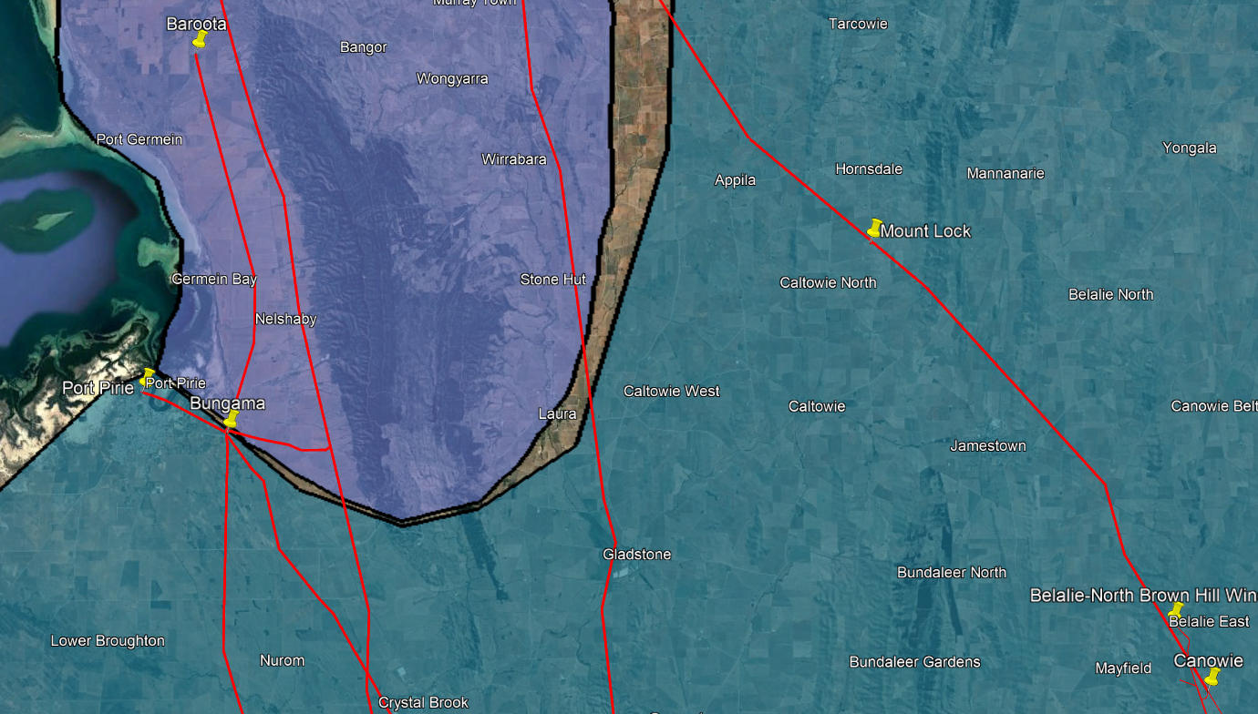

**Figure 7:** The Iron Triangle to the Mid North transmission line connections.

**Table 3:** Summary of the transmission lines connecting the Iron Triangle to the Mid North region.

|  |  |  |  |
| --- | --- | --- | --- |
| Iron Triangle Substation | Mid North Substation | Voltage (kV) | Rating (MW) |
| Baroota | Bungama | 132 | 12 |
| Davenport | Bungama | 275 | 455 |
| Davenport | Brinkworth | 275 | 455 |
| Davenport | Mt Lock | 275 | 572 |
| **Total** |  |  | **1494** |

# Mid North to Riverland

Two transmission lines facilitate the connection of the Mid North to the Riverland as shown in Figure 8. The top line is Robertstown to North West Bend 132kV line rated at 135MW and Morgan-Whyalla pipeline 2 to Morgan-Whyalla pipeline 1 132kV line rated at 184MW. The total transmission capacity between the Mid North and the Riverland is 319MW as shown in Table 4 below.

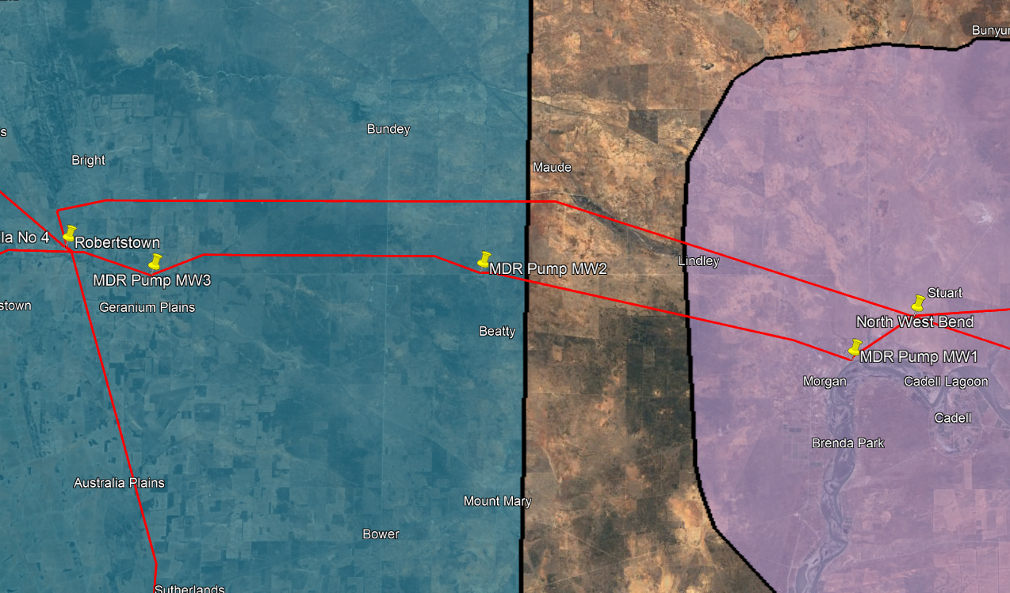

**Figure 8:** The Mid North to the Riverland transmission line connections.

**Table 4:** Summary of the transmission lines connecting the Mid North to the Riverland region.

|  |  |  |  |
| --- | --- | --- | --- |
| Mid North Substation | Riverland Substation | Voltage (kV) | Rating (MW) |
| Robertstown | North West Bend | 132 | 135 |
| Morgan-Whyalla Pipeline 1 | Morgan-Whyalla Pipeline 1 | 132 | 184 |
| **Total** |  |  | **319** |

# Mid North to South East

As depicted in Figure 9, three transmission lines facilitate the connection of the Mid North region to the South East. The first line is the 132kV Mobilong to Tailem Bend line rated at 183MW. The next two lines are the 275kV double circuit lines from Tungkillo to Tailem Bend, rated at 594MW and 459MW, respectively. The total transmission capacity between the Mid North and the South East is 319MW as shown in Table 5 below.

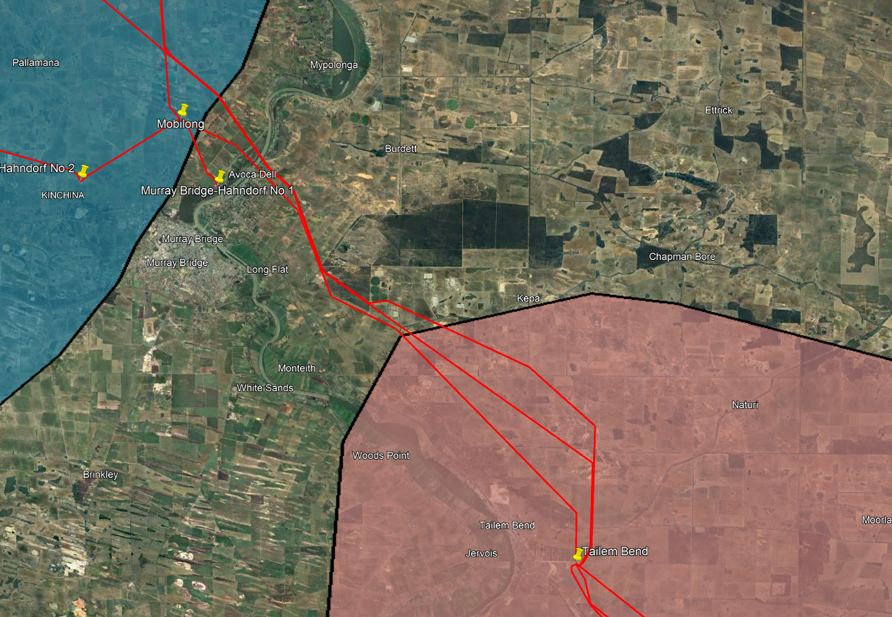

**Figure 9:** The Mid North to the South East transmission line connections.

**Table 5:** Summary of the transmission lines connecting the Mid North to the South East region.

|  |  |  |  |
| --- | --- | --- | --- |
| Mid North Substation | South East Substation | Voltage (kV) | Rating (MW) |
| Mobilong | Tailem Bend | 132 | 183 |
| Tungkillo | Tailem Bend | 275 | 594 |
| Tungkillo | Tailem Bend | 275 | 459 |
| Total |  |  | 1236 |

# Riverland to Victoria North

One of the interconnectors between SA and Victoria is the 220kV DC Murraylink interconnector which connects the Riverland to the northern part of Victoria which is displayed in Figure 10. As outlined in ElectraNet’s TAPR, this interconnector has an import rating of 220MW into SA and an export rating of 150MW out of SA [1].

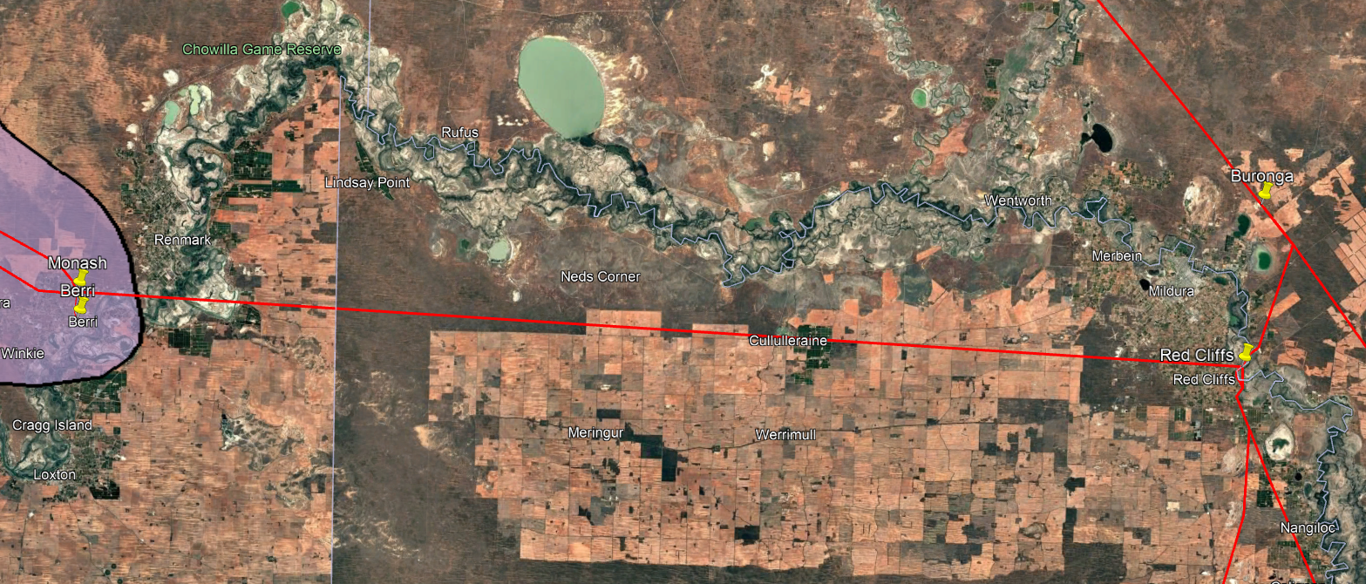

**Figure 10:** Interconnector between the Riverland region and northern Victoria.

# South East to Victoria South

The second interconnector between SA and Victoria is the 275kV Heywood interconnector that connects the South East to the southern part of Victoria which is displayed in Figure 11. As outlined in ElectraNet’s TAPR, this interconnector has an import rating of 600MW into SA and an export rating of 550MW out of SA [1].

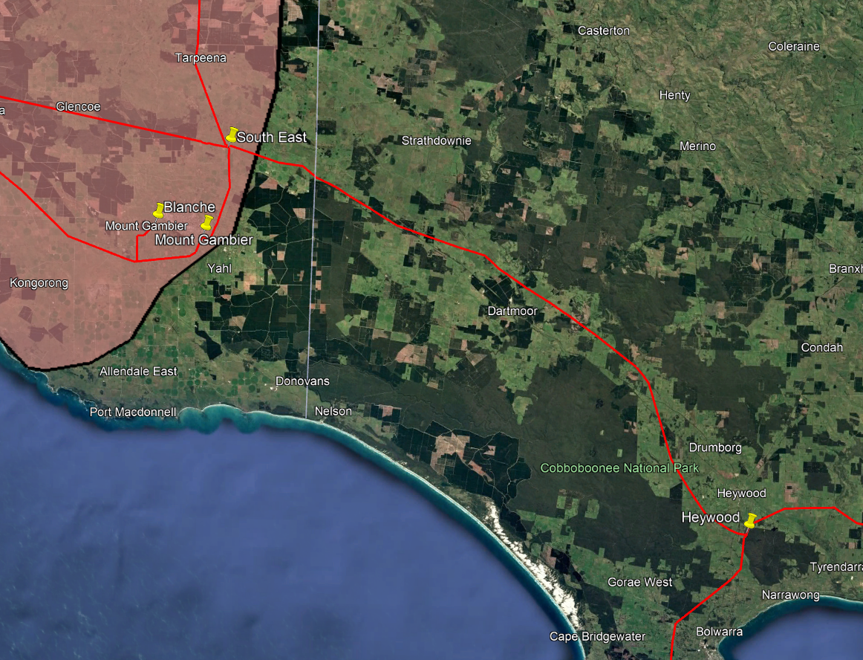

**Figure 11:** Interconnector between the South East region and southern Victoria.

# Mid North to NSW

PEC is the final interconnector of SA which connects SA to NSW. For illustrative purposes, the interconnector is drawn away from the existing lines as shown in Figure 12. This interconnector is currently under construction but once complete will have a transfer capacity of 800MW between SA and NSW [1].

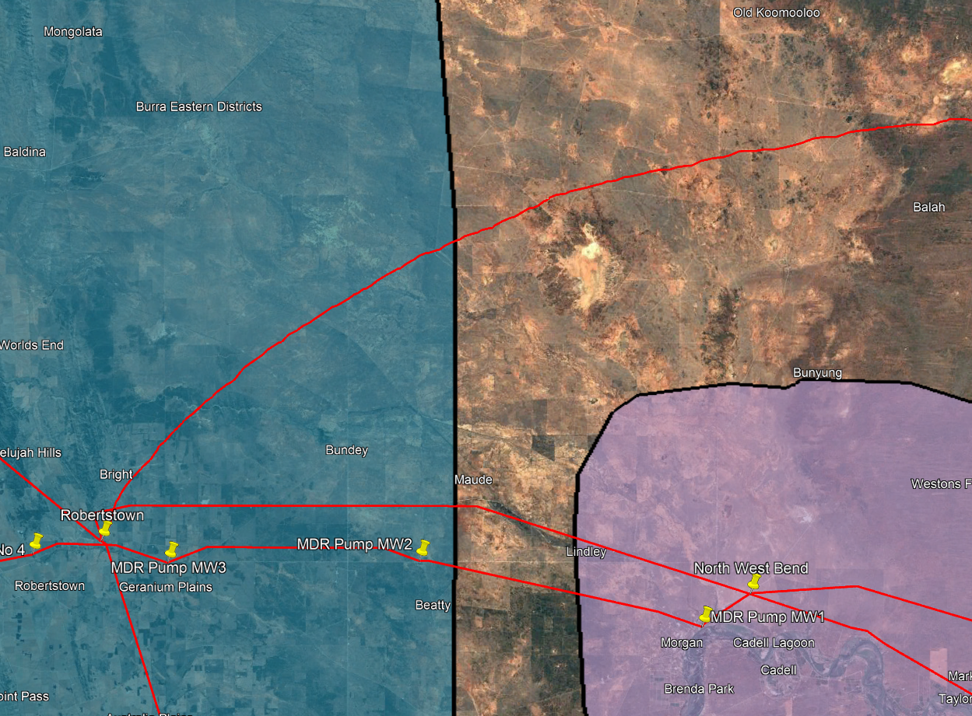

**Figure 12:** Interconnector between the Mid North region and NSW.

The import and export capacities of the South Australian interconnectors are summarised in Table 6. Interestingly, the export capacity is both Heywood and Murraylink is less than the import capacity.

**Table 6:** Import and export capacity of the SA interconnectors under normal operating conditions.

|  |  |  |
| --- | --- | --- |
| Interconnector | Import Capacity (MW) | Export Capacity (MW) |
| Heywood | 600 | 550 |
| Murraylink | 220 | 150 |
| PEC | 800 | 800 |

The findings of this section can be culminated into a single matrix as shown in Table 7. Each entry represents the transfer capacity between two regions and is read row then column. For example, the transfer capacity from the South East region to southern Victoria is 550MW however, the transfer capacity from southern Victoria to the South East region is 600MW. The transfer capacity between South Australian regions is assumed to be the same in the forward and reverse directions.

**Table 7:** Regional transfer capacities listed in MWs.

|  |  |  |  |  |  |  |  |  |  |  |
| --- | --- | --- | --- | --- | --- | --- | --- | --- | --- | --- |
| Region | Adelaide Metro | Eyre Peninsula | Iron Triangle | Upper North | Mid North | Riverland | South East | Murraylink | Heywood | PEC |
| **Adelaide Metro** | 0 | 0 | 0 | 0 | 4425 | 0 | 0 | 0 | 0 | 0 |
| **Eyre Peninsula** | 0 | 0 | 496 | 0 | 0 | 0 | 0 | 0 | 0 | 0 |
| **Iron Triangle** | 0 | 496 | 0 | 1355 | 1494 | 0 | 0 | 0 | 0 | 0 |
| **Upper North** | 0 | 0 | 1355 | 0 | 0 | 0 | 0 | 0 | 0 | 0 |
| **Mid North** | 4425 | 0 | 1494 | 0 | 0 | 319 | 1236 | 0 | 0 | 800 |
| **Riverland** | 0 | 0 | 0 | 0 | 319 | 0 | 0 | 150 | 0 | 0 |
| **South East** | 0 | 0 | 0 | 0 | 1236 | 0 | 0 | 0 | 550 | 0 |
| **Murraylink** | 0 | 0 | 0 | 0 | 0 | 220 | 0 | 0 | 0 | 0 |
| **Heywood** | 0 | 0 | 0 | 0 | 0 | 0 | 600 | 0 | 0 | 0 |
| **PEC** | 0 | 0 | 0 | 0 | 800 | 0 | 0 | 0 | 0 | 0 |